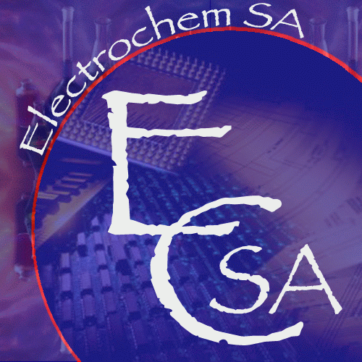
Electrochemistry at Nanostructured Interfaces
5th International Symposium on Electrochemistry

University of the Western Cape,

Library Auditorium

Bellville, SOUTH AFRICA
11-14 August 2019



AUTHOR REGISTRATION FORM and ABSTRACT SUBMISSION TEMPLATE
NAME

SURNAME

TITLE | Mr /Mrs / Ms /Dr / Prof. / Other …Ms……………………………………………….
COMPANY/UNIVERSITY
ADDRESS

 | Dialing code: ……… Number: …………………………..
FAX NUMBER | Dialing code............. Number .............................
EMAIL

ORAL  POSTER  | ABSTRACT TITLE:

Thematic areas include but are not limited to:
- Nanostructured interfaces in heterogeneous and homogeneous catalysis;
- Nanostructured interfaces in energy transforming technologies (e.g. batteries, fuel cells, solar cells),
- Electrochemical biosensors
- Diagnostic platforms in bio-electrochemistry
- Nano-electrochemical imaging techniques and spectroscopy
- Electrochemistry of nanostructured interfaces
- Fundamental concepts of physical electrochemistry
- Electrochemistry driven solutions to real world solutions
- Other
Conference timeline:
Abstract Submission opens: 22 February 2019
Early Bird Registration opens: 22 March 2019
Deadline for Early bird registration: 22 June 2019
All Registration closes: 20 July 2019
Abstract Submission closes: 20 July 2019
Completed author registration form and formatted abstract may be saved as SURNAME_Initials.DOC and submitted online http://www.saci.co.za/Scripts/Submissions/ using the following abstract submission template
Conference dates: 11- 14 August 2019
Title of the presentation
Presenting Author; Co-author1, co-author 2, …
Affiliation of the presenting author and all other authors on the paper using a numeric system (1,2,3..) for multiple affiliations
Corresponding author email

Body test of the abstract in Times new Roman font size 12, not to exceed one A4 page including diagrams and references.

